10/03/2023
Reserve Numbers
This post follows a continuous demand to integrate the extension "Reserve Numbers" in other environments.
First, let me briefly introduce the scope and benefits of this extension sample for those who have never heard about "Reserve Numbers":
Reserve Numbers allows Vault Professional Client users to create numbers consuming Vault File, Item, or Change Order numbering schemes.
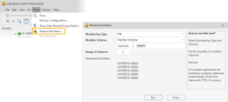
Outcome Options | Benefits
- Leverages Numbering Scheme per Entity types
  - Files (also used for Folders, Custom Objects)
  - Items
  - Change Orders
- Reserving Item Numbers creates empty items
- Generated Numbers are copied to the Windows Clipboard and can be directly pasted into tables using the CTRL+V keys, e.g., Inventor iPart or Model State part number columns.
Reserve Numbers is a Vault Data Standard extension and ships with my well-known sample configuration VDS-MFG-Sample. Now, suppose you want to copy this tool into your customized environment. In that case, you need to know some steps not as obvious as copying the additional configuration files sharing the name "*reservenumbers*".
My new instructional presentation detailed the copy and merge tasks: Download Autodesk Vault Data Standard -- Customization Sample ReserveNumbers
Happy reserving :),
Markus

